EE 527: Machine Learning Laboratory

Assignment 5

Due date: 13 Feb 2023

# Stochastic Search (SS)

Consider the objective function 𝑓(𝑥, 𝑦) given by

𝑧 = 1.7 ∗ exp [− {

(𝑥 − 3)2

+

10

(𝑦 − 3)2

10 }] + exp [− {

(𝑥 + 5)2

+

8

(𝑦 + 5)2

8 }] +

𝑥2 𝑦2

(𝑥 − 4)2

(𝑦 + 4)2

2 ∗ exp [− { 4 + 5 }] + 1.5 ∗ exp [− {

(𝑥 + 4)2

+

18

(𝑦 − 4)2

16 }] +

1.2 ∗ exp [− { 18 + 16 }]

Find the maxima 𝑧∗ = 𝑓(𝑥∗, 𝑦∗) using Stochastic Search. The search space for the solution is

given by the bounds 𝑋

= [𝑥

𝑦 ]𝑇 = [−10, −10]𝑇and 𝑋

= [𝑥

𝑦 𝑇 = [10, 10]𝑇.

𝑚𝑖𝑛

𝑚𝑖𝑛,

𝑚𝑖𝑛

𝑚𝑎𝑥

𝑚𝑎𝑥,

𝑚𝑎𝑥]

Write the following function in Python.

[𝑏𝑒𝑠𝑡𝑋, 𝑏𝑒𝑠𝑡𝑌, *maxF*] = 𝑠𝑡𝑜𝑐ℎ𝑎𝑠𝑡𝑖𝑐𝑆𝑒𝑎𝑟𝑐ℎ (𝑋𝑚𝑖𝑛 , 𝑋𝑚𝑎𝑥 , 𝑝𝑜𝑝𝑆𝑖𝑧𝑒, 𝑛𝑏ℎ𝑆𝑖𝑧𝑒, *maxItr*)

Here, 𝑧∗ = max 𝐹 = 𝑓(𝑏𝑒𝑠𝑡𝑋 = 𝑥∗, 𝑏𝑒𝑠𝑡𝑌 = 𝑦∗) is the best solution found by Stochastic Search with a Solution Population Size of *popSize* and *maxItr* Iterations (or Generations). During pure exploitation, children solutions of a parent *px* are generated in a hyper-sphere of radius *nbhSize* centered at *px*. Display the scatter plot of the solutions in each iteration on the contour plot of 𝑓(𝑥, 𝑦) to visualize the trajectories of the solutions in the population. Experiment with different values of *popSize*, *nbhSize* and *maxItr* and report the best solution.

# Travelling Salesman Problem (TSP)

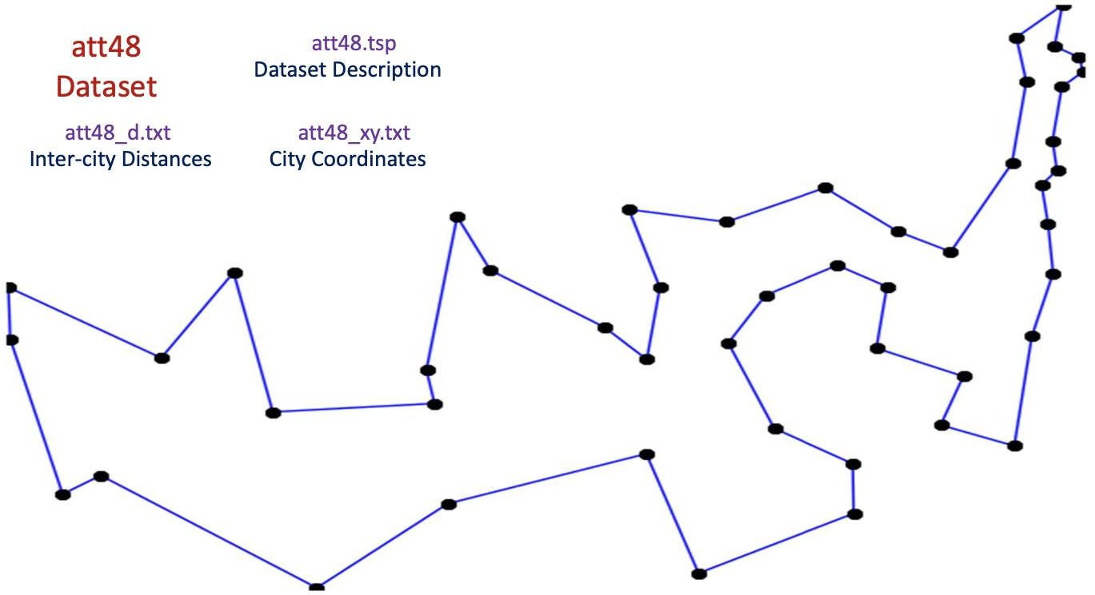

Consider the 48 city problem described by the *att48.tsp* dataset. Consider a Tour starting from *city 1* and ending at *city 1*. Search for an appropriate travel itinerary involving visits to all the remaining 47 cities in a certain sequence while minimizing the total tour length. Solve this problem using stochastic search. Choose appropriate stochastic search parameters.

1. Plot the algorithm progress *i.e.* best distance value in each iteration.
2. Plot the best tour (path connecting city sequence) obtained after each *K* (user choice for plotting) iterations.